**VISVESVARAYA TECHNOLOGICAL UNIVERSITY**

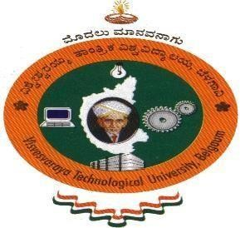**Jnana Sangama, Belagavi – 590 010**

REPORT ON

### “AICTE ACTIVITY POINTS PROGRAM”

Submitted in partial fulfillment for the requirements for the curriculum

**B.E in INFORMATION SCIENCE AND ENGINEERING**

2019 - 2023

Submitted by:

#### NAMAN PANDEY 1MV19IS038

Under the guidance of

#### Mr. Vitesh M. Asst.

#### Professor, Dept. of ISE

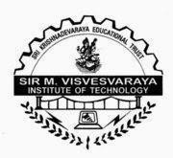

**DEPARTMENT OF INFORMATION SCIENCE AND ENGINEERING**

### SIR. M VISVESVARAYA INSTITUTE OF TECHNOLOGY

HUNASAMARANAHALLI, BENGALURU – 562 157

# Sir M Visvesvaraya Institute of Technology

[Affiliated to Visvesvaraya Technological University, Belgaum] Bangaluru-562157

2022-2023



# CERTIFICATE

Certified that the AICTE Activity Points Project carried out by **Mr. Naman Pandey** bearing **USN: 1MV19IS038** a bonafide student of **Sir M Visvesvaraya Institute of Technology** in partial fulfillment for the award of **Bachelor of Engineering** in **Information Science and Engineering** of the Visvesvaraya Technological University, Belagavi during the year 2022-23. It is certified that all theory/practicals/corrections/suggestions indicated for Activity Points havebeen executed under the directions of **Mr. Vitesh M.** The report has been approved as it satisfies the academic requirements in respect of AICTE Activity Points prescribed for the said degree.

Signature of Guide Signature of HOD Signature of Principal

|  |  |  |
| --- | --- | --- |
| **Mr. Vitesh M.**  Asst. Professor | **Dr. G C Bhanuprakash**  HOD and Professor | **Dr. Rakesh S G**  Principal |
| Dept of ISE | Dept of ISE | SIR MVIT |
| SIR MVIT | SIR MVIT |  |

# DECLARATION

I, **Mr. Naman Pandey** bearing the USN **1MV19IS038** student of 8th Semester B.E. Department of Information Science and Engineering, **Sir M Visvesvaraya Institute of Technology**, Bengaluru declare that the AICTE Activity Project work has been duly executed by me under the guidance of **Mr. Vitesh M.**, Asst Professor, Department of Information Science and Engineering, Sir MVIT, Bengaluru. The AICTE Activity Point report of the same is submitted in partial fulfilment of the requirement for the award of Bachelor of Engineering degree in Department of Information Science and Engineering by Visvesvaraya Technological University, Belgaum during the year 2022-2023.

Date: 16-05-2023 Mr. Naman Pandey

Place: Bengaluru 1MV19IS038

# ACKNOWLEDGEMENT

The satisfaction that accompanies the successful completion of the project report which would be complete only with the mention of the almighty God and the people who made it possible, whose report rewarded the effort with success of project presentation.

We are grateful to **Sir M Visvesvaraya Institute of Technology** for providing us an opportunity to enhance our knowledge through the project.

We express our sincere thanks to **Dr. Rakesh S G**, Principal, Sir MVIT, for providing us an opportunity and means to present the project.

We express our heart full thanks to **Dr. G C Bhanuprakash**, Professor and Head, Department of Information Science and Engineering, Sir MVIT, for encouragement in our project work, whose cooperation and guidance helped in nurturing this project report.

We would like to express profound thanks to the project guide **Mr. Vitesh M, Asst Professor**, AICTE Activity Point Project head and Internal Guide, Department of Information Science and Engineering for the keen interest and encouragement in our project presentation.

Finally, we would like to thank our family members and friends for standing with us through all times.

**NamanPandey 1MV19IS038**

**TABLE OF CONTENTS**

|  |  |  |  |  |
| --- | --- | --- | --- | --- |
| **Sl.**  **No.** | **Activity Name** | **Number of**  **Hours** | **Number of Activity points** | **Page No.** |
| 1  . | 21 Day Induction Programme | 40 |  | 02 |
| 2  . | Garbage Collection- Swachh MVIT Abhiyan | 8 |  | 04 |
| 3  . | CLIMATE CHANGE CAMPAIGN  By Abhikalpana NGO | 25 |  | 05-07 |
| 4  . | Student Welfare Program At Carmel Balika Vidyalaya,  Hazaribagh Jharkhand | 65 |  | 8-9 |
| 5  . | Abhikalpana Shine Sessions | 60 |  | 10-11 |
| 6  . | Go Green Initiative – Volunteer for planting the Saplings | 8 |  | 12-13 |
| 7  . | CONCLUSION |  |  | 14 |

**Total number of Hours 206**

### AICTE ACTIVITY POINT PROGRAM

To be successful as professionals, apart from technical knowledge the students should have excellent soft skills, leadership qualities and team spirit. They should have entrepreneurial capabilities and societal commitment. In order to nurture these qualities, VTU has introduced activity points to be earned by the students during their academic stay at the University covering extra-curricular and co-curricular activities.

The main activity segments are:

1. National Initiatives
2. Sports & Games
3. Cultural Activities
4. Professional Self Initiatives
5. Entrepreneurship and Innovation
6. Leadership & Management

The activities provide rich and varied experiences to the students, thereby building their knowledge, boosting creativity skills and increasing cognitive skills. Additionally, the self-confidence of learners is boosted as they explore both familiar and unfamiliar concepts in creative ways. Apart from these it also paves way for improved Academic Performance, explore varied Interests, create Broader Perspectives, builds Higher Self-esteem, Social Opportunities and Productive Breaks.

### 21 Days of Induction Programme (06-30 August 2019)

#### Day1 [05/08/2019]:

Fresher’s Day Function was held and there was a talk by Chief Guest, President, Secretary and Principal.

#### Day2 [06/08/2019]:

There was an orientation about 21 days induction program and students were allocated to respective Local Guardians.

#### Day3 [07/08/2019]:

Campus tour was conducted where students were escorted to respective departments, classrooms, labs and HOD office. Also there was an interaction between senior students and fresher’s.

#### Day4 [08/08/2019], Day5 [09/08/2019] and Day6 [10/08/2019] :

Students health check-up was done. Also there were auditions for Sports and Games, Cultural and Extra Curricular activities.

#### Day7 [11/08/2019]:

Alumni meet was organized.

#### Day8 [13/08/2019]:

NSS Activity- Planting of saplings and Swatch SIRMVIT Campus Abhiyan was carried out.

#### Day9 [14/08/2019]:

Kannada and Non-Kannada students group were made to interact with each other. Also Yoga and meditation session was held for students.

#### Day10 [16/08/2019]:

Awareness regarding Ragging and Anti-Ragging was provided to the students and there was a visit to nearby school in the afternoon session.

#### Day11 [17/08/2019]:

Hand Book and VTU Syllabus copy were distributed to the students and trial competitions in Quiz, Public Speaking, Essay writing, Rangoli and Sketching were held.

#### Day12 [18/08/2019]:

Students were lead from respective classrooms to new auditorium and there was an eminent lecture on Universal Human Values.

#### Day13 [20/08/2019]:

There was an introductory session to Language and traditional food habits of Karnataka. Also lecture and video presentation regarding Health Tips were given.

#### Day14 [21/08/2019]:

Awareness session was conducted with respect to Drug, Tobacco and Aids.

**Day15 [23/08/2019]**: Students were taught about time management, decision making and setting long term goals.

#### Day16 [24/08/2019]:

An Eminent Sportsman addressed the students followed by Anti sexual harassment squad introducing themselves and their activities.

#### Day17 [25/08/2019]:

There was an Eminent lecture on inter-disciplinary projects.

#### Day18 [27/08/2019]:

Final round of Debate, Quiz, Rangoli competition was organized.

#### Day19 [28/08/2019]:

Students were lead to sports ground and final round of sports competitions were conducted.

#### Day20 [29/08/2019]:

Final round of cultural competitions were held to decide the best two contenders.

#### Day21 [30/08/2019]:

On the last day of induction program cultural competitions were conducted to decide the winner and runner. Finally, a valedictory function of induction program was held and prizes were distributed to respective winners and runners.

**Garbage Collection-** Swachh MVIT Abhiyan

( 5th October 2019 )

**Number of hours spent: 8**

Participated in one day cleaning program organized at Sir MVIT. This event took place on 5th October 2019.

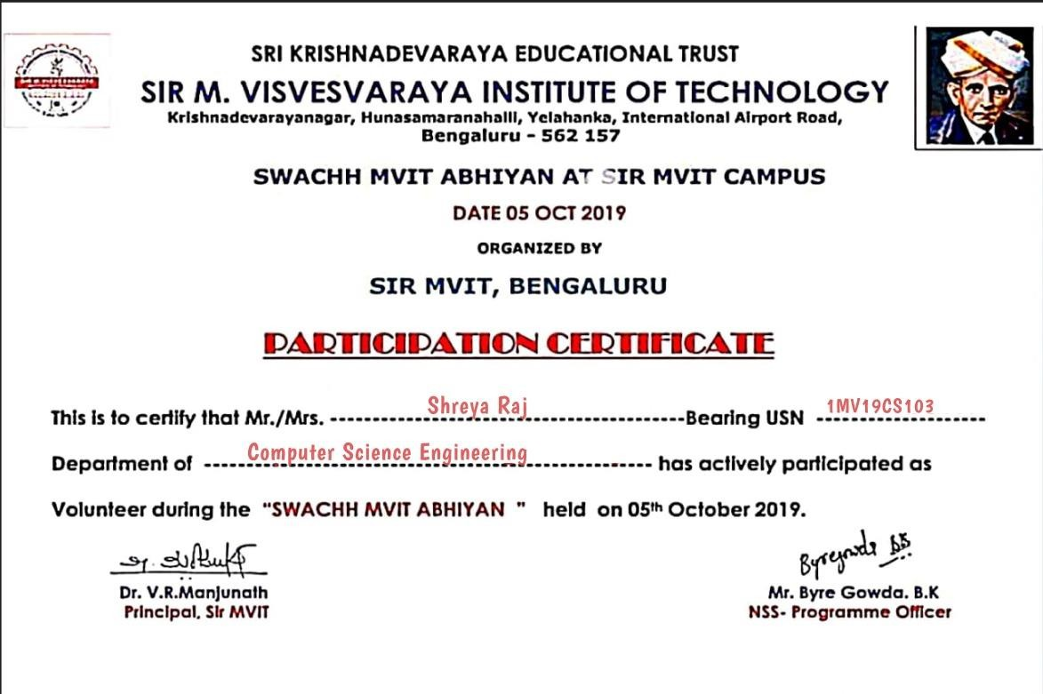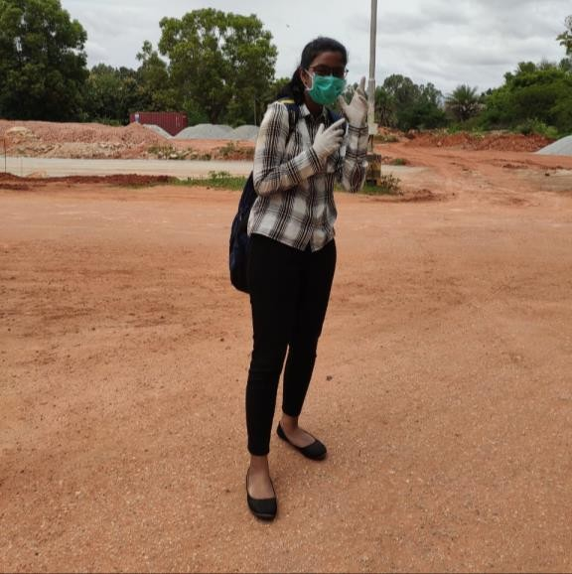

**CLIMATE CHANGE CAMPAIGN**

**By Abhikalpana NGO**

#### Number of hours spent: 25

Team Abhikalpana had planned to have a Climate Change Campaign in our college. These were the events which were conducted on various days:

On the first day of our campaign, we displayed the handmade posters and collage which were made by the volunteers and our NGO kids on the noticeboard of various departments to spread the awareness about the campaign.

Second day we had paper bag distribution. The paper bags were made by the volunteers and were given to the college canteen so that they can use them for food parcel and reduce the usage of plastic bags. We also customized the existing dustbins in college campus with quotes on climate change written on it.

Third day we had quiz and eco awareness youth contest. The topics for both the events were climatic changes, global warming, various types of pollutions, non-biodegradable pollutants, etc.

Fourth day we had picking while walking contest, where the students participated in pair and within the time limit the participants had to collect the waste from all over the college campus. The team which collected the more waste was the winner. After that we had Debate session which was conducted by DEBSOC, the debating society of our college.

Overall the campaign was a success with the help of all the volunteers and we need to have more Campaigns like this to spread awareness among the people.

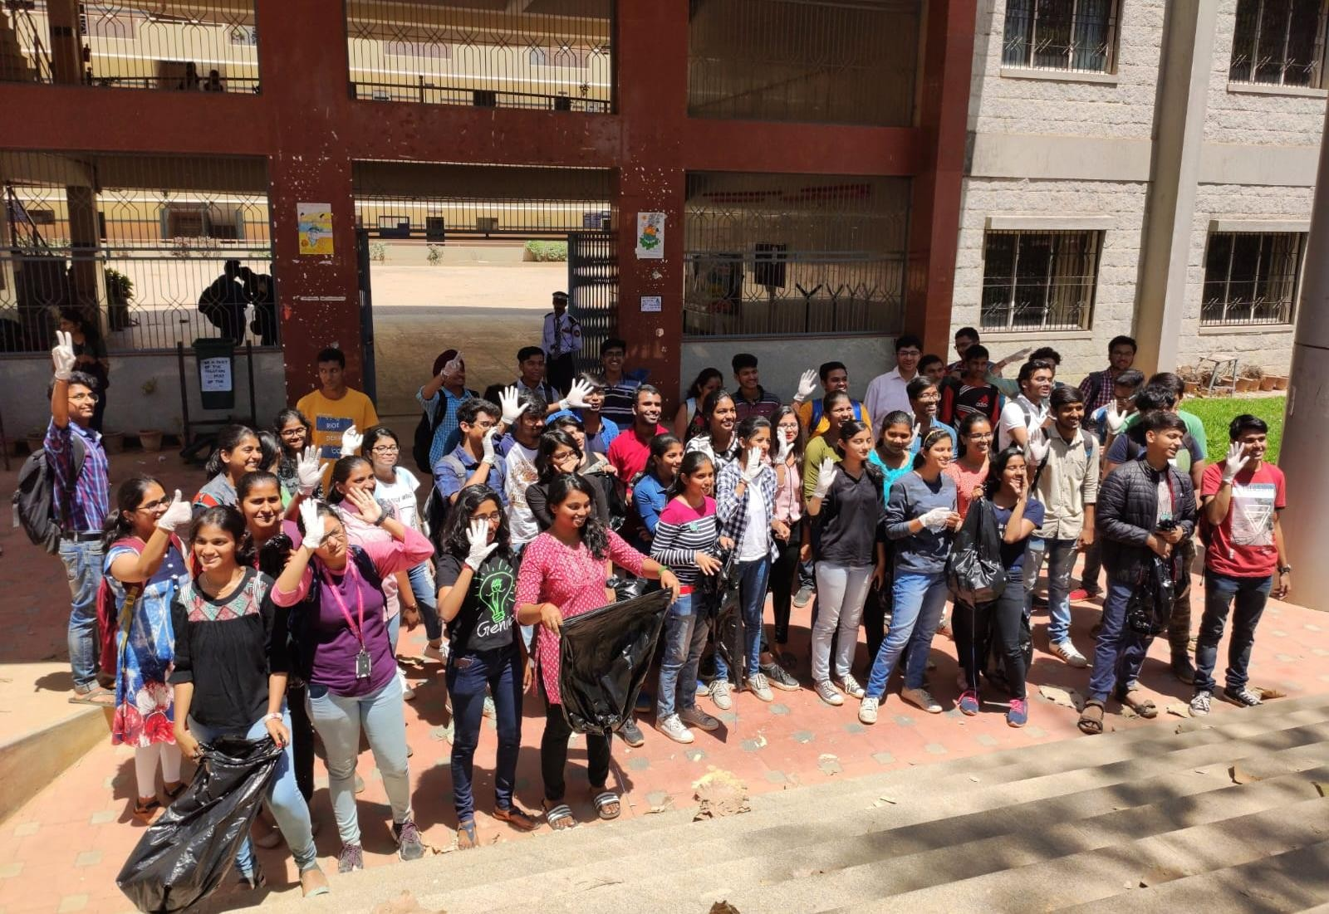

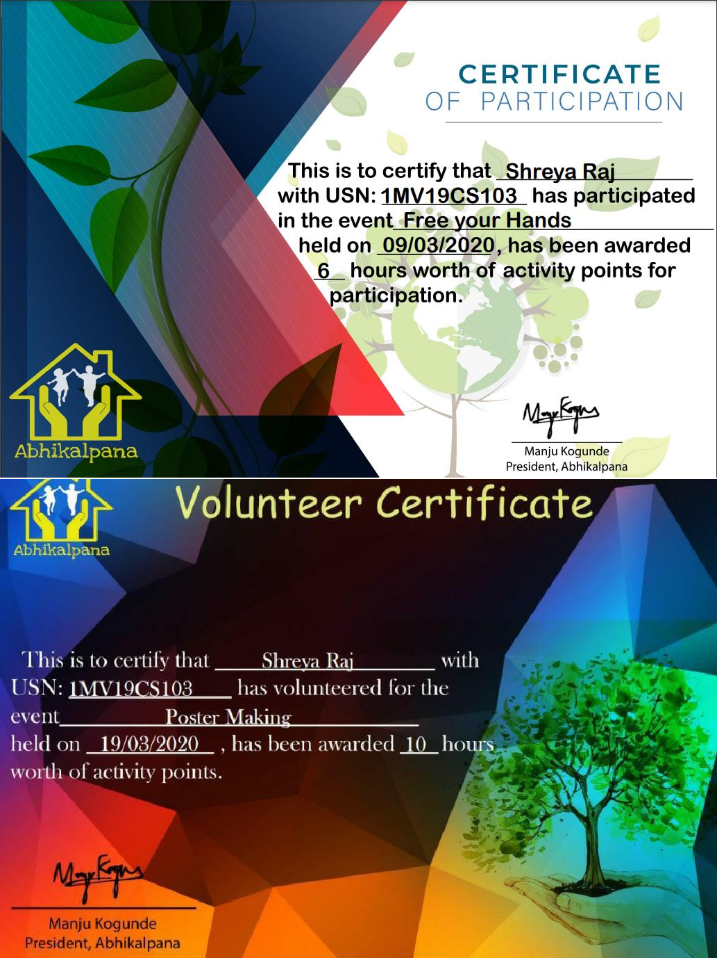

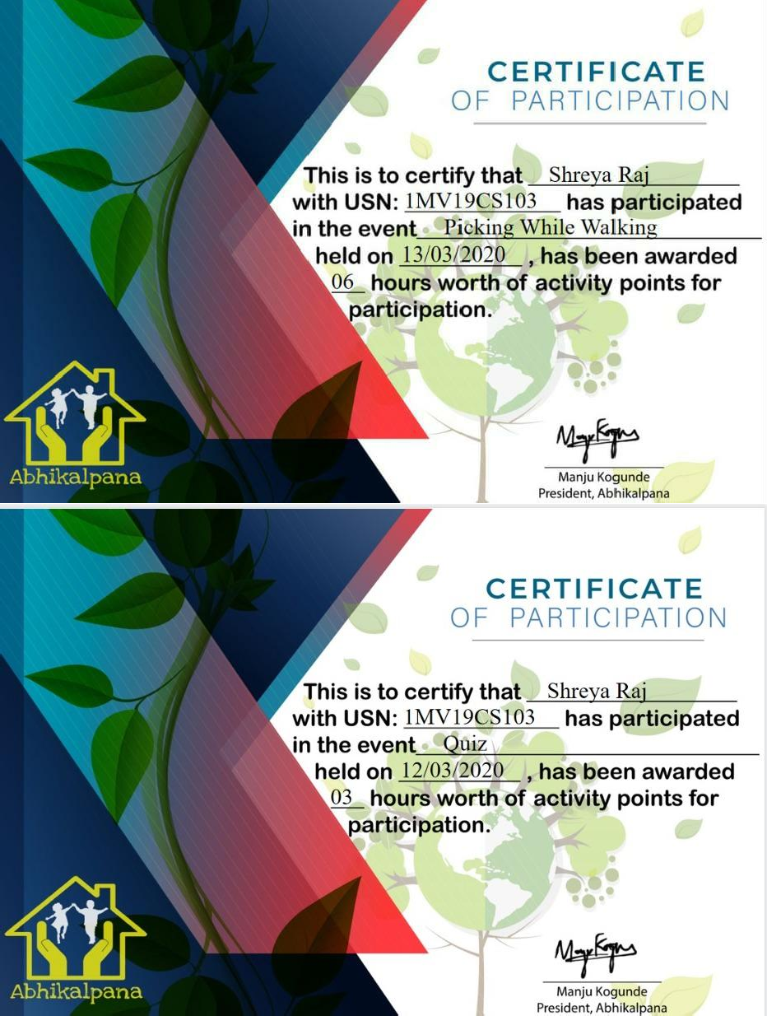

### Student Welfare Program

**At Carmel Balika Vidyalaya, Hazaribagh Jharkhand**

## ( 1st to 10th October 2020)

#### Number of hours spent: 65

Former students of Carmel Blika Vidyalaya were invited to teach underprivileged primary school students at Carmel Balika Vidyalaya in Hazaribag town, Jharkhand. It was a 10 day progam. The aim is to provide education to children who might not have access to it otherwise due to their economic circumstances. By imparting knowledge and skills, We hope to empower these students to create better futures for themselves and their families. It's a fulfilling experience to be a part of their learning journey, and I'm grateful for the opportunity to make a positive impact in their lives.

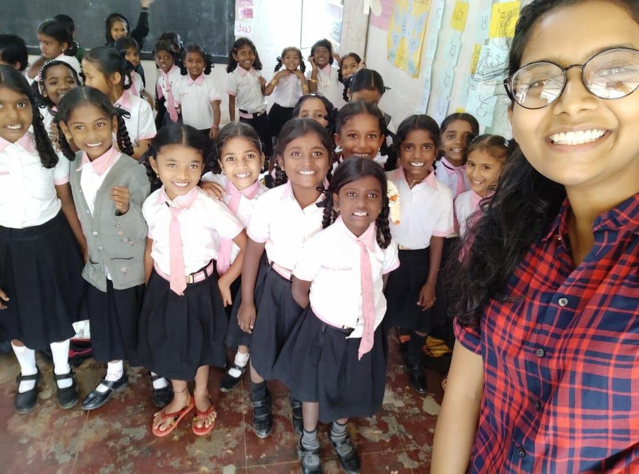

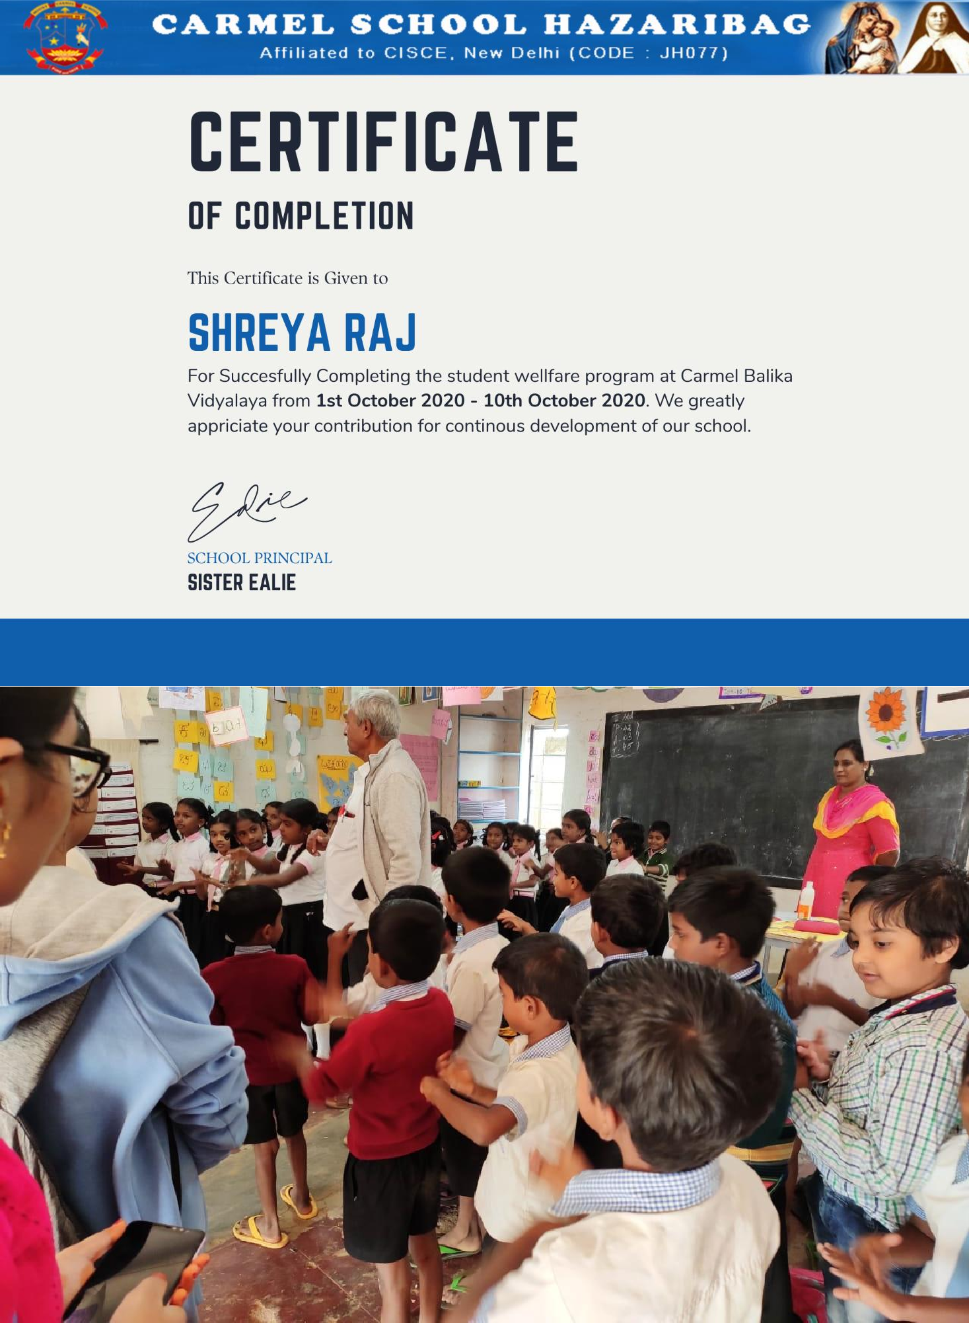

**ABHIKALPANA SHINE SESSIONS**

**(August 2019- March 2023)**

**Number of hours spent: 60**

Shine helps the underprivileged kids get academic support and overall development. Every Sunday Volunteers of Abhikalpana visit various nests and help them study, play with them and also make art and craft.

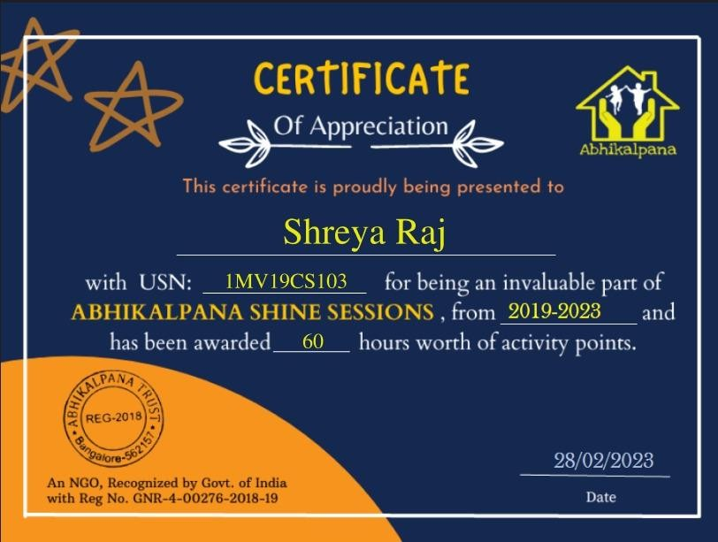

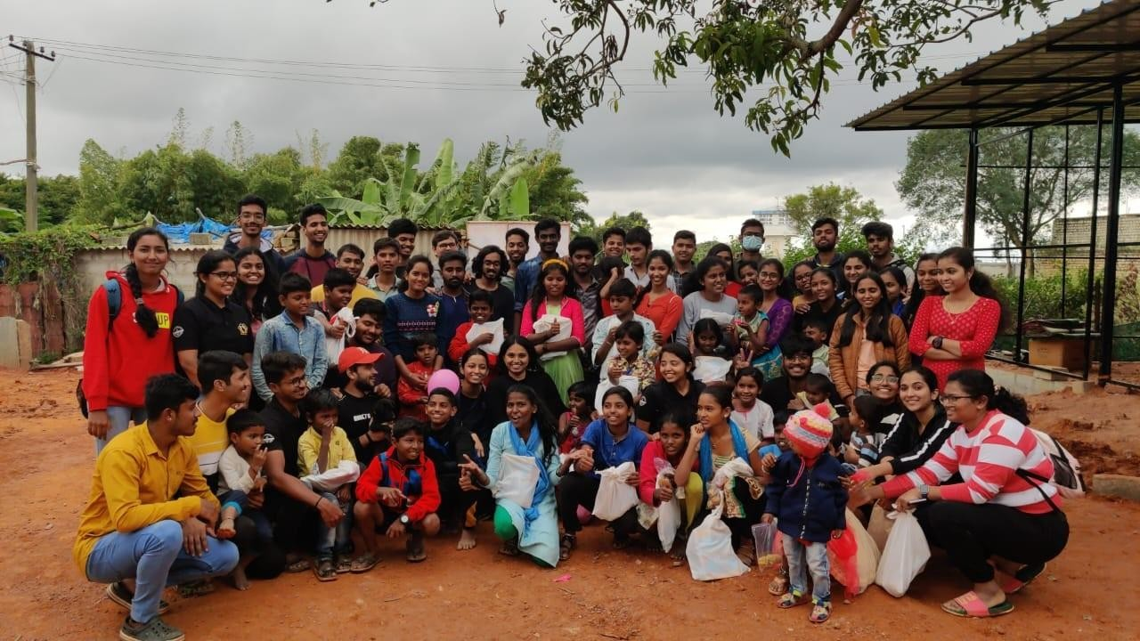

# Go Green Initiative – Volunteer for planting the Saplings

## ( 17 July 2021 )

#### Number of hours spent: 8

Volunteered in one day GO Green Initiative program by Sir MVIT. Planting the sapling involves packaging the saplings in the form of root balls, bare-root plants or in containers.

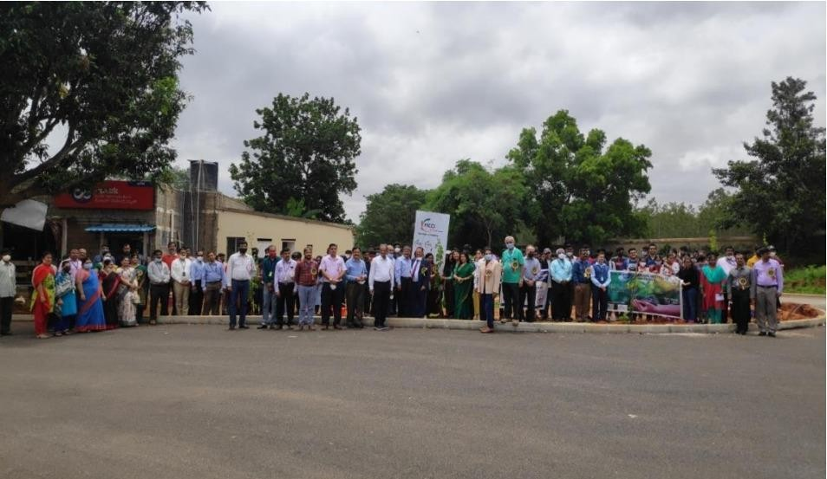

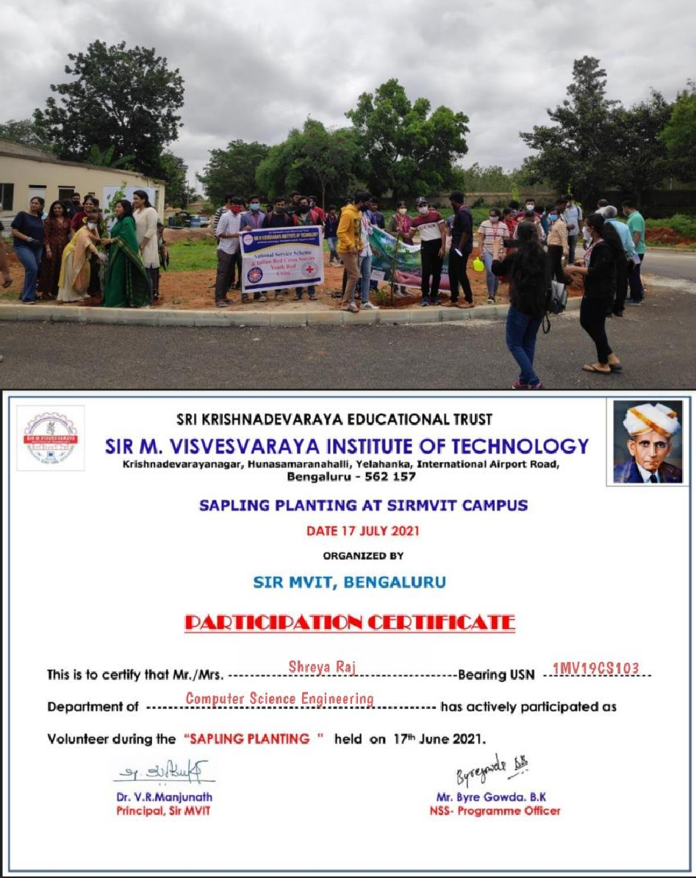

**Conclusion**

The Activity Points Program was a very innovative way to get students to dabble in volunteering work and be more sensitive to the social concerns that exist in this day and age. I was able to cultivate many virtues and skills through the activities that I took part in. Some being, time management, creative thinking, awareness regarding topics and so on.

In total, I have done around **206 hours** of activities, which is equal to gaining

**credit points** according to the AICTE guidelines for the activity points program.